1. SIMPLE WEB PAGE
simplewebpage.tsx
import React from "react";
const SimpleWebPage: React.FC = () => {
return (
<div>
<h1>Welcome to My Web Page</h1>
<p>This is a simple web page created using React and TypeScript.</p>
<h2>About</h2>
<p>This page demonstrates basic elements like headings, text and image.</p>
<h2>Image</h2>
<img
src="https://via.placeholder.com/200"
alt="sample"
/>
<h2>List Example</h2>
<ul>
<li>React</li>
<li>TypeScript</li>
<li>Web Development</li>
</ul>
</div>
);
};
export default SimpleWebPage;

Output:
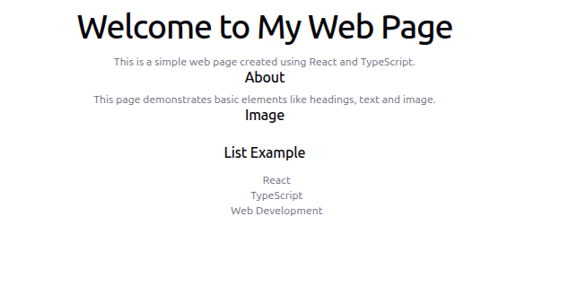
2. WEBSITE
website.tsx
import React from "react";
const Website: React.FC = () => {
return (
<div>
<header>
<h1>My Website</h1>
</header>
<section>
<h2>Home</h2>
<p>Welcome to the home section of the website.</p>
</section>
<section>
<h2>Services</h2>
<ul>
<li>Web Development</li>
<li>UI Design</li>
<li>Software Development</li>
</ul>
</section>
<section>
<h2>Contact</h2>
<p>Email: example@email.com</p>
</section>
<footer>
<p>Copyright 2026</p>
</footer>
</div>
);
};
export default Website;

Output:
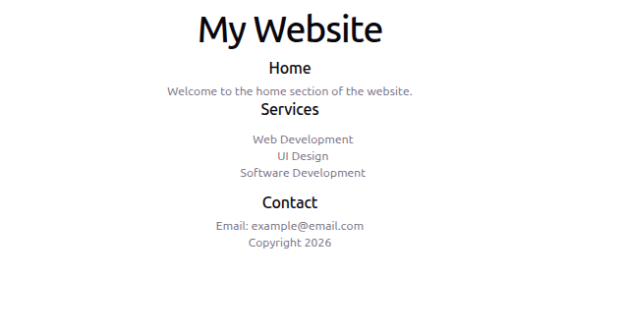

3. TODO LIST
todolist.tsx
import React, { useState } from "react";
interface Task {
id: number;
text: string;
}
const TodoList: React.FC = () => {
const [task, setTask] = useState<string>("");
const [tasks, setTasks] = useState<Task[]>([]);
const addTask = () => {
if(task.trim() === "") return;
const newTask: Task = {
id: Date.now(),
text: task
};
setTasks([...tasks, newTask]);
setTask("");
};
const deleteTask = (id: number) => {
setTasks(tasks.filter((t) => t.id !== id));
};
return (
<div>
<h2>Todo List</h2>
<input
type="text"
placeholder="Enter task"
value={task}
onChange={(e)=>setTask(e.target.value)}
/>
<button onClick={addTask}>Add</button>

<ul>
{tasks.map((t)=>(
<li key={t.id}>
{t.text}
<button onClick={()=>deleteTask(t.id)}>Delete</button>
</li>
))}
</ul>
</div>
);
};
export default TodoList;
Output:

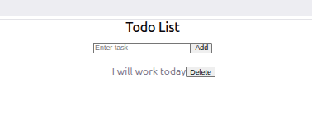

4.CALCULATOR
calculator.tsx
import React, { useState } from "react";
const Calculator: React.FC = () => {
const [num1,setNum1] = useState<number>(0);
const [num2,setNum2] = useState<number>(0);
const [result,setResult] = useState<number>(0);
const add = () => {
setResult(num1 + num2);
};
const subtract = () => {
setResult(num1 - num2);
};
const multiply = () => {
setResult(num1 * num2);
};
const divide = () => {
if(num2 === 0){
alert("Cannot divide by zero");
return;
}
setResult(num1 / num2);
};
return(
<div>
<h2>Simple Calculator</h2>
<input
type="number"
placeholder="Enter first number"
onChange={(e)=>setNum1(Number(e.target.value))}
/>
<br/>
<input
type="number"
placeholder="Enter second number"
onChange={(e)=>setNum2(Number(e.target.value))}
/>
<br/><br/>
<button onClick={add}>Add</button>
<button onClick={subtract}>Subtract</button>
<button onClick={multiply}>Multiply</button>
<button onClick={divide}>Divide</button>
<h3>Result: {result}</h3>
</div>
);

};
export default Calculator;

Output:
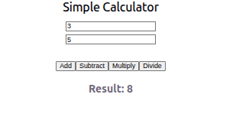

5. VOTING
voting.tsx
import React, { useState } from "react";
const Voting: React.FC = () => {
const [countA,setCountA] = useState<number>(0);
const [countB,setCountB] = useState<number>(0);
return(
<div>
<h2>Voting App</h2>
<button onClick={()=>setCountA(countA+1)}>Vote A</button>
<p>{countA}</p>
<button onClick={()=>setCountB(countB+1)}>Vote B</button>
<p>{countB}</p>
</div>
);
};
export default Voting;
Output:
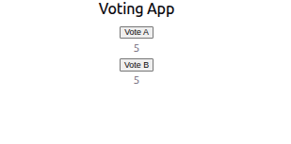

6. LOGIN FORM
login.tsx
import React, { useState } from "react";
const Login: React.FC = () => {
const [username,setUsername] = useState<string>("");
const [password,setPassword] = useState<string>("");
const handleLogin = () => {
alert(`Username: ${username} Password: ${password}`);
};
return(
<div>
<h2>Login</h2>
<input
type="text"
placeholder="Username"
onChange={(e)=>setUsername(e.target.value)}
/>
<input
type="password"
placeholder="Password"
onChange={(e)=>setPassword(e.target.value)}
/>
<button onClick={handleLogin}>Login</button>
</div>
);
};
export default Login;
Output:
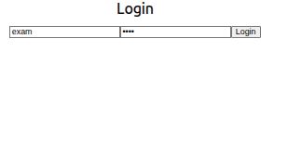

7. SEARCHFILTER
searchfilter.tsx
import React, { useState } from "react";
const SearchFilter: React.FC = () => {
const items: string[] = ["Apple","Banana","Orange","Mango"];
const [search,setSearch] = useState<string>("");
return(
<div>
<h2>Search Filter</h2>
<input
type="text"
onChange={(e)=>setSearch(e.target.value)}
/>
<ul>
{items
.filter(item=>item.toLowerCase().includes(search.toLowerCase()))
.map((item,index)=>(
<li key={index}>{item}</li>
))}
</ul>
</div>
);
};
export default SearchFilter;
Output:
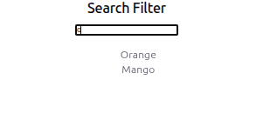

8. GREATEST AMOUNG THREE NUMBERS
greatest.tsx
import React, { useState } from "react";
const Greatest: React.FC = () => {
const [a,setA] = useState<number>(0);
const [b,setB] = useState<number>(0);
const [c,setC] = useState<number>(0);
const [result,setResult] = useState<number>(0);
const findGreatest = () => {
setResult(Math.max(a,b,c));
};
return(
<div>
<h2>Greatest Number</h2>
<input type="number" onChange={(e)=>setA(Number(e.target.value))}/>
<input type="number" onChange={(e)=>setB(Number(e.target.value))}/>
<input type="number" onChange={(e)=>setC(Number(e.target.value))}/>
<button onClick={findGreatest}>Find</button>
<p>{result}</p>
</div>
);
};
export default Greatest;
Output:
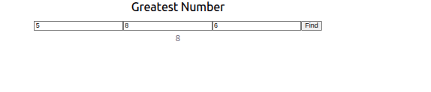

9. GREETING MESSAGE
greeting.tsx
import React, { useState } from "react";
const Greeting: React.FC = () => {
const [name,setName] = useState<string>("");
return(
<div>
<h2>Greeting</h2>
<input
onChange={(e)=>setName(e.target.value)}
/>
<p>Hello {name}</p>
</div>
);
};
export default Greeting;
Output:


10. COUNTER
counter.tsx
import React, { useState } from "react";
const Counter: React.FC = () => {
const [count,setCount] = useState<number>(0);
return(
<div>
<h2>Counter</h2>
<button onClick={()=>setCount(count+1)}>Increase</button>
<p>{count}</p>
</div>
);
};
export default Counter;
Output:


11. STUDENT PROFILE
studentprofile.tsx
import React, { useState } from "react";
const StudentProfile: React.FC = () => {
const [name,setName] = useState<string>("");
const [course,setCourse] = useState<string>("");
return(
<div>
<h2>Student Profile</h2>
<input
placeholder="Name"
onChange={(e)=>setName(e.target.value)}
/>
<input
placeholder="Course"
onChange={(e)=>setCourse(e.target.value)}
/>
<p>Name : {name}</p>
<p>Course : {course}</p>
</div>
);
};
export default StudentProfile;
Output:
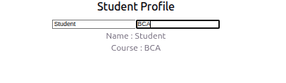

12. CHAT
chat.tsx
import React, { useState } from "react";
const Chat: React.FC = () => {
const [message,setMessage] = useState<string>("");
const [chat,setChat] = useState<string[]>([]);
const send = () => {
setChat([...chat,message]);
setMessage("");
};
return(
<div>
<h2>Chat</h2>
<input
value={message}
onChange={(e)=>setMessage(e.target.value)}
/>
<button onClick={send}>Send</button>
<ul>
{chat.map((msg,index)=>(
<li key={index}>{msg}</li>
))}
</ul>
</div>
);
};
export default Chat;

Output:


13. PRODUCTS
products.tsx
import React from "react";
const Products: React.FC = () => {
const products: string[] = ["Laptop","Phone","Tablet"];
return(
<div>
<h2>Product List</h2>
<ul>
{products.map((p,index)=>(
<li key={index}>{p}</li>
))}
</ul>
</div>
);
};
export default Products;

Output:

14. FEEDBACK
feedback.tsx
import React, { useState } from "react";
const Feedback: React.FC = () => {
const [feedback,setFeedback] = useState<string>("");
const submit = () => {
alert(feedback);
};
return(
<div>
<h2>Feedback</h2>
<textarea
onChange={(e)=>setFeedback(e.target.value)}
></textarea>
<button onClick={submit}>Submit</button>
</div>
);
};
export default Feedback;

Output:


15. FORM VALIDATION
formvalidation.tsx
import React, { useState } from "react";
const FormValidation: React.FC = () => {
const [email,setEmail] = useState<string>("");
const [error,setError] = useState<string>("");
const validate = () => {
if(!email.includes("@")){
setError("Invalid Email");
}
else{
setError("Valid Email");
}
};
return(
<div>
<h2>Form Validation</h2>
<input
onChange={(e)=>setEmail(e.target.value)}
/>
<button onClick={validate}>Check</button>
<p>{error}</p>
</div>
);
};
export default FormValidation;

Output:


